**Milestone Assignment 3**

**Github Link:**

**Screenshot:**

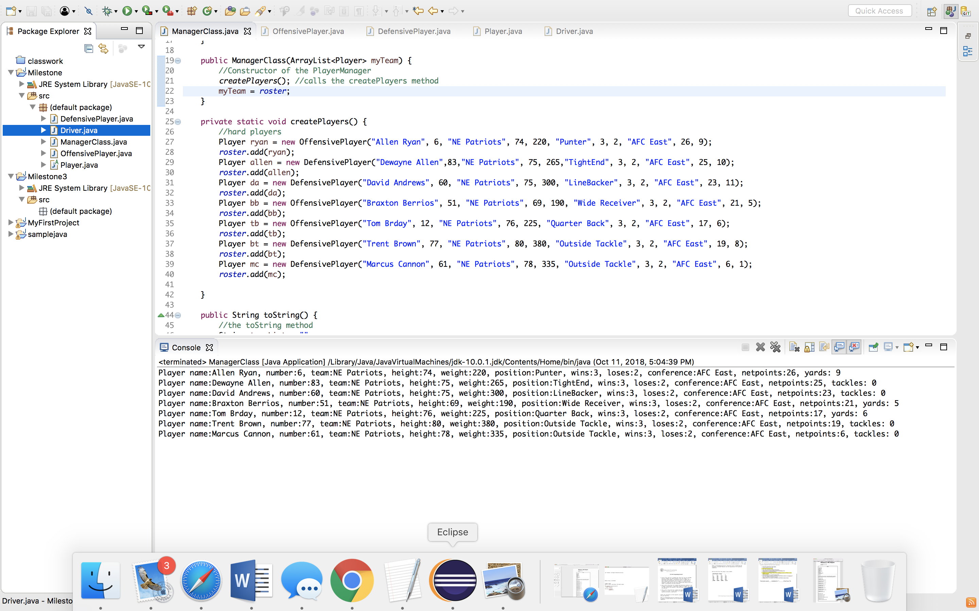

**UML Diagram:**